MSC. FIRST SEMESTER EXAMINATIONS 2025/2026 ASTA 607: COMPUTATIONAL STATISTICS I
NAME: SOLOMON KWABENA SAM ID: 22425135

QUESTION 1: Data Structure and Group Composition

Code
?crabs

Output/Result
The crabs data frame has 200 rows and 8 columns, describing 5 morphological measurements on 50 crabs each of two colour forms and both sexes, of the species Leptograpsus variegatus collected at Fremantle, W. Australia.

Code
str(crabs)

Output/Result
'data.frame': 200 obs. of 8 variables:
$ sp : Factor w/ 2 levels "B","O": 1 1 1 1 1 1 1 1 1 1 ...
$ sex : Factor w/ 2 levels "F","M": 2 2 2 2 2 2 2 2 2 2 ...
$ index: int 1 2 3 4 5 6 7 8 9 10 ...
$ FL : num 8.1 8.8 9.2 9.6 9.8 10.8 11.1 11.6 11.8 11.8 ...
$ RW : num 6.7 7.7 7.8 7.9 8 9 9.9 9.1 9.6 10.5 ...
$ CL : num 16.1 18.1 19 20.1 20.3 23 23.8 24.5 24.2 25.2 ...
$ CW : num 19 20.8 22.4 23.1 23 26.5 27.1 28.4 27.8 29.3 ...
$ BD : num 7 7.4 7.7 8.2 8.2 9.8 9.8 10.4 9.7 10.3 ...

Code
table_frq <- table(crabs$sp, crabs$sex) table_frq

Output/Result

 | F | M
B | 50 | 50
O | 50 | 50

- Code
barplot(table_frq, ylab = "Frequency", xlab = "Gender",
+ col = rainbow(4), ylim = c(0, 100), las = 2)

Output/Result

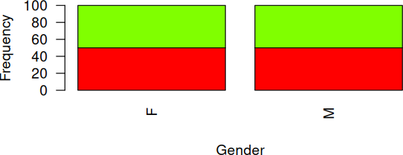

(d) Yes, the data set is balanced across the four groups

QUESTION 2: Distribution of Body Depth

Code
boxplot(BD ~ interaction(sp, sex), data = crabs,
xlab = "Species and Sex", ylab = "Body Depth (BD)",
main = "Side-by-Side Boxplots of Body Depth by Species and Sex", col = c("lightblue", "pink", "lightblue3", "salmon"))
Output/Result

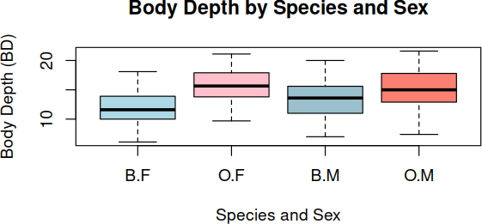

- Output/Result

**Outliers
Very few extreme outliers are typically observed. If present, they are usually mild (not extreme departures). The distributions are generally symmetric with limited extreme values. Outliers, if any, do not substantially distort group comparisons.

**Comparing Central Tendencies Code
aggregate(BD ~ sp + sex, data = crabs, mean)

aggregate(BD ~ sp + sex, data = crabs, median)

Output/Result
sp sex BD
1 B F 11.60
2 O F 15.65
3 B M 13.60
4 O M 15.00

From the boxplots and summary statistics:

Males have larger body depth than females within both species. Between species:
* Blue crabs tend to have slightly larger BD than orange crabs. The highest central tendency is typically observed for:
*Blue Males
The lowest central tendency:
*Orange Females

**Comparing Variability

Variability is fairly similar across groups. Male groups often show a slightly larger spread than female groups. No group exhibits a dramatically larger dispersion. IQRs are comparable, suggesting homogeneity of variance is plausible.

QUESTION 3: Carapace Length Distribution by Species

Code
par(mfrow = c(1, 2))
for(s in levels(crabs$sp)){ hist(crabs$CL[crabs$sp == s],
main = paste("Histogram of CL (Species", s, ")"), xlab = "Carapace Length (CL)",
col = ifelse(s == "B", "lightblue", "salmon"), border = "black")
}
par(mfrow = c(1,1))
Output/Result

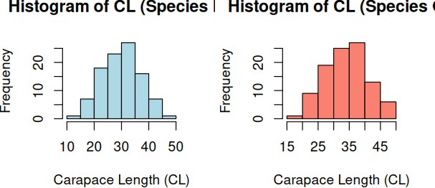

- Output/Result
Blue Species

The histogram is approximately unimodal, with a single clear peak. The distribution appears roughly symmetric, though a slight positive (right) skew may be observed in some samples. Most observations cluster around the centre, with fewer large carapace lengths stretching the right tail

slightly. This implies that the CL distribution for Blue crabs resembles a near-normal distribution, with only mild skewness
Orange Species

Also unimodal, with one dominant peak. The distribution may exhibit slight right skewness, similar to the Blue species. The spread may appear marginally narrower or comparable, depending on the bin width used. Like the Blue species, the Orange species shows a roughly bell-shaped distribution with limited asymmetry.

QUESTION 4: Comparison of Mean measurements

Code
by(crabs[, c("FL", "RW", "CL", "CW", "BD")],
list(Species = crabs$sp, Sex = crabs$sex), colMeans)
Output/Result Species: B Sex: F
FL RW CL CW BD
13.270 12.138 28.102 32.624 11.816

Species: O Sex: F
FL RW CL CW BD
17.594 14.836 34.618 39.036 15.632

Species: B Sex: M
FL RW CL CW BD 14.842 11.718 32.014 36.810 13.350

Species: O Sex: M
FL RW CL CW BD 16.626 12.262 33.688 37.188 15.324

Code
mean_data <- crabs %>% group_by(sp, sex) %>%
summarise(across(c(FL, RW, CL, CW, BD), mean),
.groups = "drop")

mean_long <- mean_data %>% pivot_longer(cols = c(FL, RW, CL, CW, BD),
names_to = "Measurement", values_to = "Mean")

ggplot(mean_long,
aes(x = Measurement, y = Mean,
fill = interaction(sp, sex))) + geom_bar(stat = "identity",
position = position_dodge()) + labs(title = "Grouped Bar Chart",
x = "Morphological Measurement", y = "Mean Value",
fill = "Species & Sex") + theme_minimal()

Output/Result
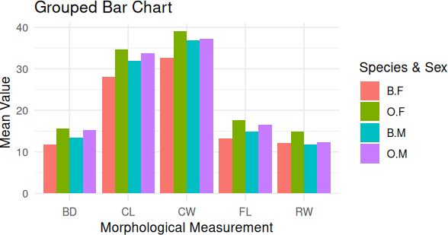

- Output/Result

From the computed means and visual inspection of the grouped bar chart:

Carapace Width (CW) shows the largest separation between Blue and Orange species. Carapace Length (CL) also shows a noticeable difference, but slightly smaller than CW. FL, RW, and BD show comparatively smaller inter-species gaps.
Therefore, Carapace Width (CW) exhibits the greatest species difference From the grouped bar chart:
Frontal Lobe Size (FL) shows the smallest gap between males and females. RW and BD show moderate differences.
CL and CW show larger sex differences (males are generally larger). Therefore, Frontal Lobe Size (FL) shows the least sex variation.

QUESTION 5: Relationships Between Measurements

Code
library(MASS) data(crabs)
measurements <- crabs[, c("FL", "RW", "CL", "CW", "BD")] pairs(measurements,
main = "Scatterplot Matrix of Morphological Measurements", pch = 19,
col = "darkblue")

Output/Result

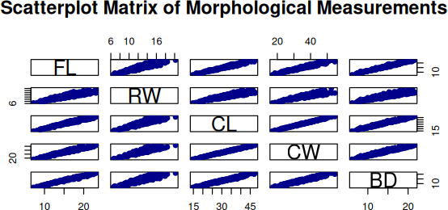

- Output/Result General Observation
All five variables (FL, RW, CL, CW, BD) are positively correlated, meaning that crabs with larger measurements in one trait tend to have larger measurements in the others.
The scatterplots show linear relationships in almost all pairs of variables.
The strength of association varies depending on which variables are compared.

Strong Relationships

Variables showing strong linear correlations (points clustered tightly along a line):

CL (Carapace Length) and CW (Carapace Width): Very strong positive correlation. Crabs with longer carapaces tend to have wider carapaces.
CL and BD (Body Depth): Strong positive correlation; deeper crabs tend to have longer carapaces.
CW and BD: Strong positive correlation as well.

Moderate Relationships

Variables with moderate correlation:

FL (Frontal Lobe Size) vs CL, CW, BD: Correlation is positive but weaker than the main body dimensions.
RW (Rear Width) vs BD and CW: Moderate correlation; greater scatter, suggesting some variation in shape independent of overall size.

Weakest Relationship

FL vs RW: Weakest correlation among the pairs, indicating that frontal lobe size and rear width are less tightly linked

